### 

### Excel Evaluation Exam

#### Basic to Intermediate Level

**Section A: Objective Questions (2 marks each)**

* + What keyboard shortcut opens the 'Find and Replace' dialog box?
    - a) Ctrl + F
    - b) Ctrl + H
    - c) Ctrl + R
    - d) Ctrl + G
  + Which function is used to find the average of a range of values?
    - a) SUM
    - b) AVG
    - c) MEAN
    - d) AVERAGE
  + How do you apply bold formatting to selected text in a cell?
    - a) Ctrl + B
    - b) Ctrl + U
    - c) Ctrl + I
    - d) Ctrl + C
  + Which of the following is a correct formula to add the values in cells A1 and B1?
    - a) =A1+B1
    - b) =SUM(A1:B1)
    - c) =ADD(A1,B1)
    - d) =A1*B1
  + To sort a column in ascending order, which menu option would you use?
    - a) Data -> Sort A to Z
    - b) Data -> Sort Z to A
    - c) Data -> Filter
    - d) Data -> Text to Columns
  + Which function allows you to filter data based on specific criteria?
    - a) VLOOKUP
    - b) HLOOKUP
    - c) FILTER
    - d) SORT
  + Which menu option would you use to highlight cells with values greater than 1000?
    - a) Home -> Format as Table
    - b) Home -> Conditional Formatting -> Highlight Cells Rules -> Greater Than
    - c) Home -> Styles -> Cell Styles
    - d) Home -> Editing -> Clear
  + What is the default chart type in Excel?
    - a) Pie Chart
    - b) Line Chart
    - c) Column Chart
    - d) Bar Chart
  + Which function checks a condition and returns one value if true and another if false?
    - a) IF
    - b) VLOOKUP
    - c) INDEX
    - d) MATCH
  + What does a cell reference like $A$1 mean?
    - a) Relative reference
    - b) Absolute reference
    - c) Mixed reference
    - d) Error reference

**Section B: Objective Questions (3 marks each)**

* + What does the fourth argument in the VLOOKUP function specify?
    - a) The lookup value
    - b) The column index number
    - c) The range to search
    - d) Whether to find an exact or approximate match
  + Which feature allows you to create a dropdown list in a cell?
    - a) Conditional Formatting
    - b) Data Validation
    - c) Text to Columns
    - d) Filter
  + What is the main purpose of a PivotTable?
    - a) To sort data
    - b) To create charts
    - c) To summarize data
    - d) To filter data
  + Which function can combine text from multiple cells into one cell?
    - a) CONCATENATE
    - b) COMBINE
    - c) JOIN
    - d) MERGE
  + How would you write an IF function to display "Pass" if cell B1 is greater than or equal to 50, and "Fail" otherwise?
    - a) =IF(B1>=50, "Pass", "Fail")
    - b) =IF(B1>50, "Pass", "Fail")
    - c) =IF(B1>=50, Pass, Fail)
    - d) =IF(B1>50, Pass, Fail)
  + Which chart type would be best to show the trend of data over time?
    - a) Pie Chart
    - b) Line Chart
    - c) Column Chart
    - d) Bar Chart
  + What is the main advantage of using INDEX and MATCH over VLOOKUP?
    - a) They are easier to use
    - b) They are faster
    - c) They can search both horizontally and vertically
    - d) They do not require sorting of the data
  + Which function returns the number of characters in a text string?
    - a) LEN
    - b) COUNT
    - c) TEXT
    - d) CHAR
  + Which function would you use to calculate the number of days between two dates?
    - a) DAYS
    - b) DATEDIF
    - c) DATE
    - d) DAY
  + In the provided dataset "SalesData.xlsx", what is the total sales amount for the product "Widget A"?
    - a) 5000
    - b) 7500
    - c) 10000
    - d) 12500

### Datasets for Practical Questions

For questions that require working with datasets, you can create a simple dataset in an Excel file named "SalesData.xlsx" with the following structure:

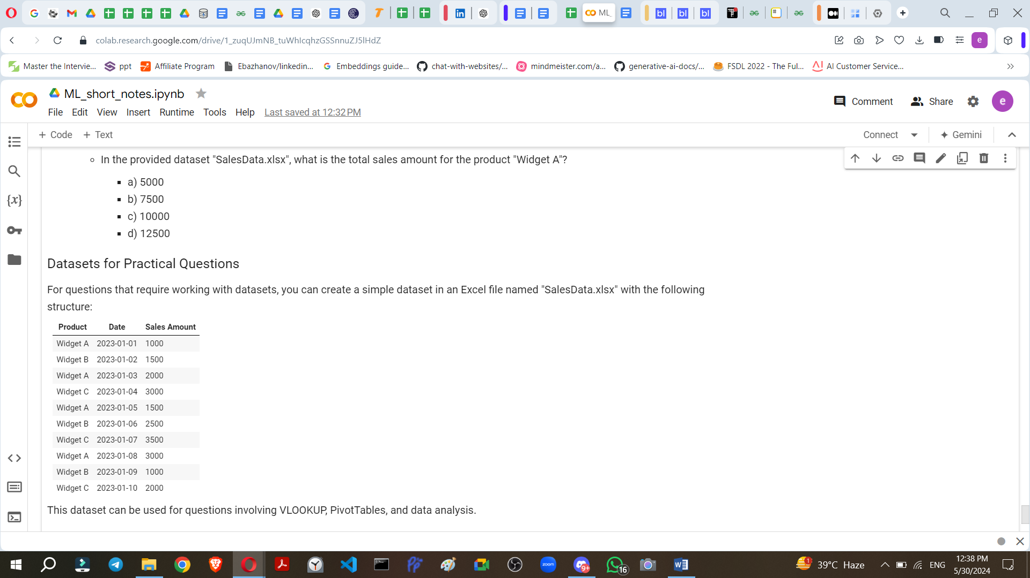

This dataset can be used for questions involving VLOOKUP, PivotTables, and data analysis.

### Answers

Here are the answers for each question:

**Section A:**

1. a) Ctrl + F
2. d) AVERAGE
3. a) Ctrl + B
4. a) =A1+B1
5. a) Data -> Sort A to Z
6. c) FILTER
7. b) Home -> Conditional Formatting -> Highlight Cells Rules -> Greater Than
8. c) Column Chart
9. a) IF
10. b) Absolute reference

**Section B:**

1. d) Whether to find an exact or approximate match
2. b) Data Validation
3. c) To summarize data
4. a) CONCATENATE
5. a) =IF(B1>=50, "Pass", "Fail")
6. b) Line Chart
7. c) They can search both horizontally and vertically
8. a) LEN
9. b) DATEDIF
10. b) 7500 (sum of 1000 + 2000 + 1500 + 3000 from the dataset for "Widget A")